IDENTIFICATION OF UNAUTHORIZED CONSTRUCTION
DEFINITION :
- Construction without written permission from the Executive Authority of the Local Body.
Reasons for Unauthorized Constructions.
- Eagerness of owners/developers for maximum utilization of site to get maximum returns;
- High land cost and smaller plot sizes;
- Building regulations not being accepted by applicants;
- Non-regulation of unauthorized layouts both by owners and authorities;
- Land use controls;
- Ineffective and Inadequate development control machinery;
- Dependence on lower staff for detection, issue of notices and demolition;
- Frequent interference of Courts in Unauthorized Constructions;
- Non-fixation of clear responsibilities on lower staff, officers and Municipal Commissioners;
- Lack of co-ordination between parastatal departments Viz. Electricity, Water Supply, Engineering, Revenue, Health (Trade Licences) etc., for controlling unauthorized development activity
Disadvantages of Unauthorized Constructions
- Unauthorized Constructions affect the planned development of the city causing various problems to community at large;
- Unauthorized Constructions affect the general health of the occupants denying them natural light & air;
- Serious traffic problems are created on account of not providing required parking space;
- Provision of urban Infrastructure is becomes an uphill task on account of unauthorized and irregular development of buildings;
- Roads with proper width and adequate open spaces could not be provided due to unapproved layouts;
- Change in usage of buildings is creating problems to traffic, safety and health of the residents of the neighbourhood.

Process for Identification of Unauthorized Constructions:

- Field inspection
- Instructions from the Higher Authority
- Petitions from individuals / Government Departments
- Press
- Corporator / Councillor / Public Representatives
Amendments to Municipal Corporation Act, 1955.
3-11 Levy of penalty on unauthorized constructions:
(i) Sub section (3) of section 220 of Municipal Corporation Act, 1955 stipulates levy of penalty of 25% on the amount of property tax levied on all unauthorized constructions till such unauthorized constructions are demolished or regularized. Rule 26 (g) of A.P. Building Rules, 2012 stipulates that the local body shall collect three times the property tax as penalty from the owner / occupier of all unauthorized constructions and building constructed without sanctioned building plan. It may be stated that there is no statutory backing for levy of penalty at two times the property tax on all unauthorized constructions as stipulated in A.P. Building Rules, 2012 .
(V) In the circumstances, it is suggested to amend Municipal Corporation Act suitably for levying penalty at a percentage of property tax as shown hereunder on all unauthorized constructions and deviations in sanctioned plans to act as a deterrent on the persons resorting to unauthorized constructions:
a) | Up to ten percent violation from permissible setbacks only in respect of floors permitted in a sanctioned plan | Twenty five percent of property tax as penalty
b) | More then ten percent violation of permissible setbacks only in respect of floors permitted in a sanctioned plan | Fifty percent of property tax as penalty
c) | Unauthorized floors over the permitted floors in a sanction plan | Hundred percent of property tax as penalty
d) | Total unauthorized construction | Hundred percent of property tax as penalty

Sub-section (3) of Section 220 of Municipal Corporation Act, 1955 may be renumbered as Section 220-A with heading as levy of penalty on unauthorized constructions and the section may be amended suitably.
(g) The functional/line agencies dealing with electric power, water supply, drainage and sewerage shall not give regular connections to the building unless such Occupancy Certificate is produced, or alternatively may charge 3 times the tariff till such time Occupancy Certificate is produced. This condition shall also be applicable to all unauthorized constructions and buildings constructed without sanctioned building plan. In addition to the above, the Local Body shall collect every year two times the property tax as penalty from the owner / occupier.
(h) The Registration Authority shall register only the permitted built up area as per the sanctioned building plan and only upon producing and filing a copy of such sanctioned building plan. On the Registration Document it should be clearly mentioned that the registration is in accordance with the sanctioned building plan in respect of setbacks and number of floors.
(i) The financial agencies / institutions shall extend loan facilities only to the permitted built up area as per the sanctioned building plan.
Section: 455. Completion of certificates, permission to occupy or use:
Every person shall, within one month after the completion of the erection or re-erection of building or the execution of any such work as is described in Section 343 deliver or send or cause to be delivered or sent to the Commissioner at his office, a notice in writing of such completion accompanied by a certificate in the form specified in the Bye-law signed and subscribed in the manner so specified, and shall give to the Commissioner all necessary facilities for the inspection of such building or of such work and shall apply for permission to occupy the building.
No person shall occupy or permitted to be occupy any such building, or use or permit to be used the building or part thereof affected by any work, until:
- Permissions has been received from the Commissioner in this behalf; or
- The Commissioner has failed for twenty-one days after receipt of the notice of completion to intimate his refusal of the said permission.
Section:455-A. Regulation of Buildings constructed without sanctioned plan:-
The Commissioner may regularize constructions made without obtaining sanctioned plan, subject to fulfilling the following conditions:
- Submission of building plans to the competent authority duly paying all categories of fee and charges.
- The construction shall be subject to the condition that all parameters laid down in relevant statutes, Master Plan, Zonal Development Plan, Building Bye-Laws, Buildings Rules and other relevant Government Orders including Andhra Pradesh Fire Service Act, 1999 and the National Building Code are satisfied;
- Payment of penalty equivalent to thirty three percent (33%) of the various categories of fees and charges payable by the applicant for obtaining building permission in addition to the regular fee and other charges payable.
Section:461. Powers of Commissioner to direct removal of person directing unlawful work:-
  - If the Commissioner is satisfied that the erection or re-erection of any building or the execution of any such work as is described in Section 433 has been unlawfully commenced or is being unlawfully carried on upon any premises he may, by written notice, require the person directing or carrying on such erection or re-erection or execution of work to stop the same forthwith.
  - If such erection or re-erection or execution of work is not stopped forthwith, the Commissioner may direct that any person directing or carrying on such erection or re-erection or execution of work shall be removed from such premises by any police officer and may cause such steps to be taken as he may consider necessary to prevent the re-entry of such person on the premises without his permission.
  - The cost of any measures taken under sub-section (2) shall be paid by the said person.
  - “Notwithstanding anything contained in the Act, any person who, whether at his own instance or at the instance of any other person or any body including a department of the government undertakes or carries out construction or development of any and in contravention of the statutory master plan or without permission, approval or sanction or in contravention of any condition subject to which such permission, approval or sanction has been granted shall be punished with imprisonment for a term which may extend to three years, or with fine which may extend to ten percent of the value of land or building including land in question as fixed by the Registration Department at the time of using the land or building. Provided that the fine imposed shall, in no case be less than fifty percent of the said amount.”
Section 461-A. Powers to seal unauthorized construction / development of premises:-
- It shall be lawful for the Commissioner, at any time, before or after making an order for the removal or discontinuance of any unauthorized development or construction under Section 461, to make and order direction the sealing of such development or property or taking the assistance of police, for the purpose of carrying out the provisions of the Act.
- Where any development or property has been sealed, the Commissioner, may, for the purpose of removing or discontinuing such development or property, order such seal to be removed.
- No person shall remove such seal except,-
  - under an order made by the Commissioner, or
  - Under an order of the Appellate Tribunal on the appeal made in this behalf.

ONLINE BUILDING APPLICATION

FEATURES OF ONLINE BUILDING APPLICATION MODULE OF GHMC
GHMC has already developed Online Building Application Module and the same is under implementation in Town Planning Wing of GHMC. The Details are as follows:
- Generation of Unique Number for each building application at citizen charter including receipt / acknowledgement to the applicant.
- Generation of rejection endorsement.
- Generation of building permit with unique permit number through Module.
- Generation of occupancy certificate through module.
- Monitoring of Citizen Charter for the disposal of Building Application Including each functionary level monitoring and generation of receipts including fines if any for delay through module only.
- Uploading of Approved Building Plan to create Building History with connected documents.
The Online Building Application Module will also helpful to the citizens and Urban Local Bodies with respect to deal the issues like i.e.,
- RTI Act.
- Citizen Charter implementation and monitoring.
- Levy of property tax on buildings in deviation to the approved plans and unauthorized constructions as per the amendment to the A.P. Municipal Corporation Act. recently.

Online Entry Form
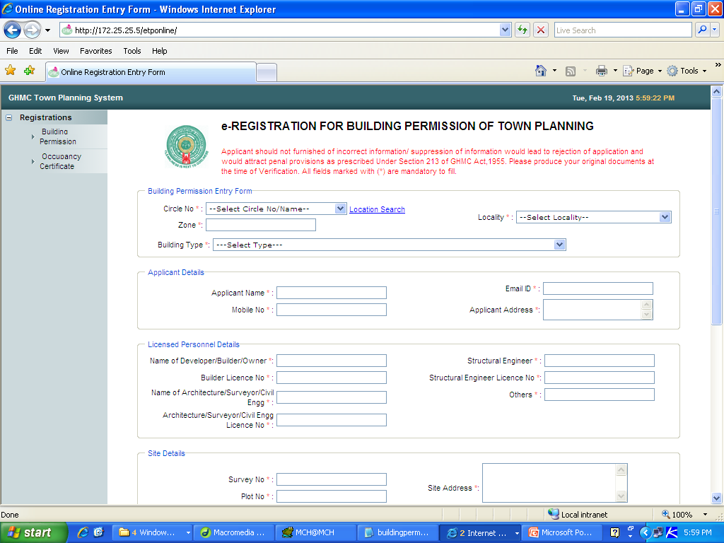

Online Entry Receipt
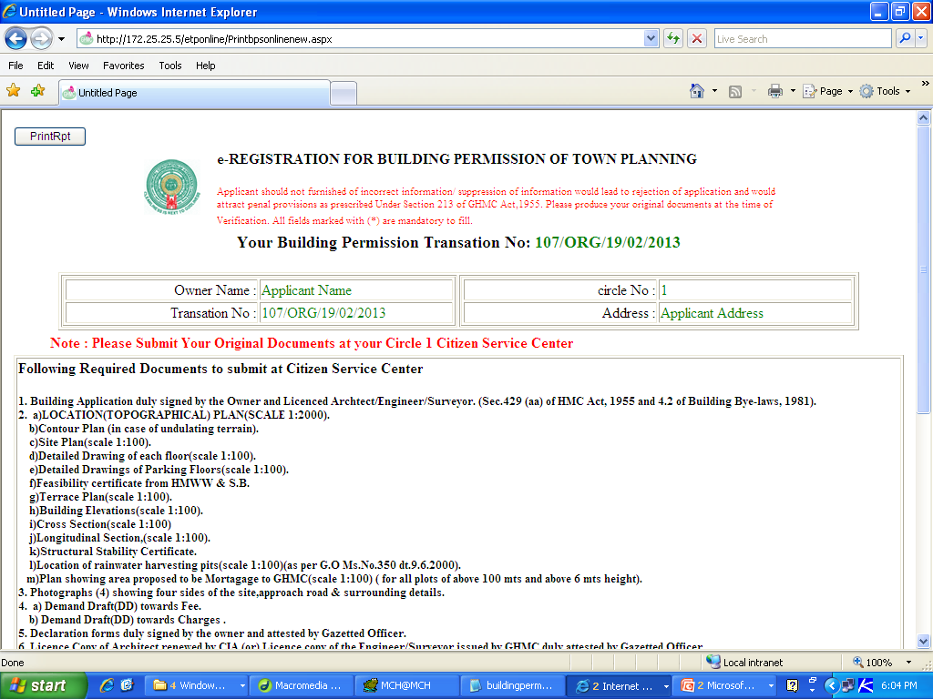
CSC Entry Form
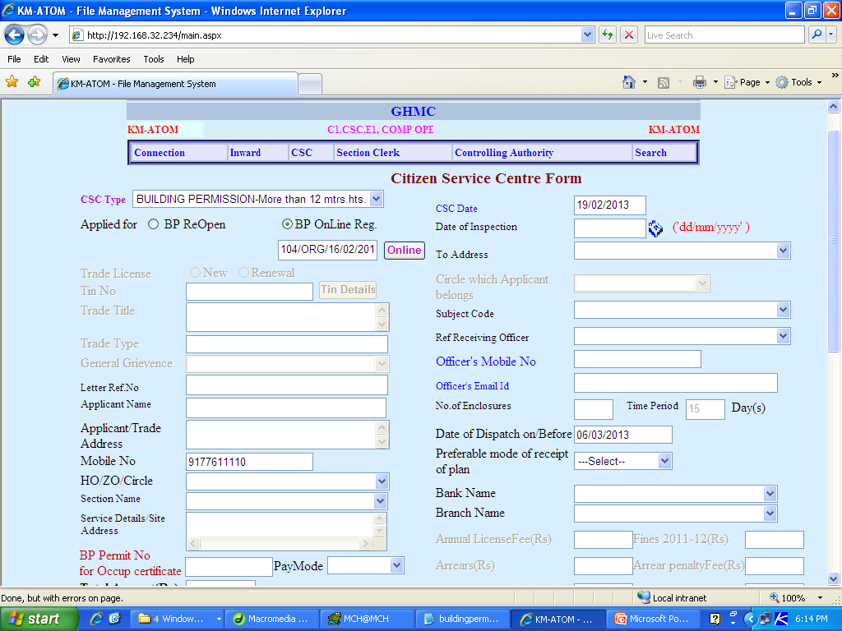
CSC Acknowledgement
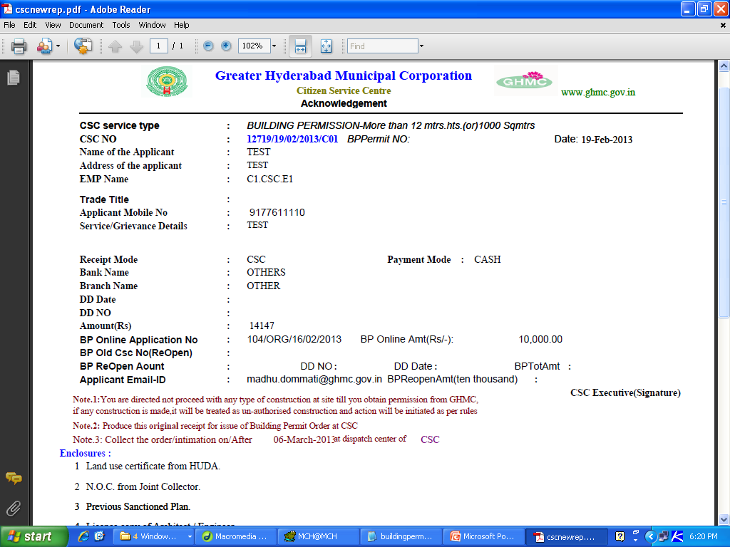

Permit Order Print
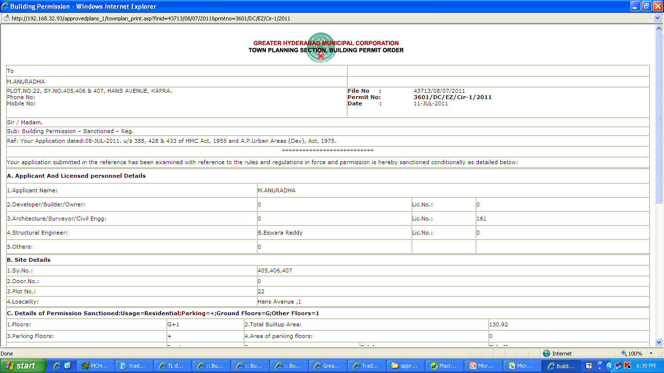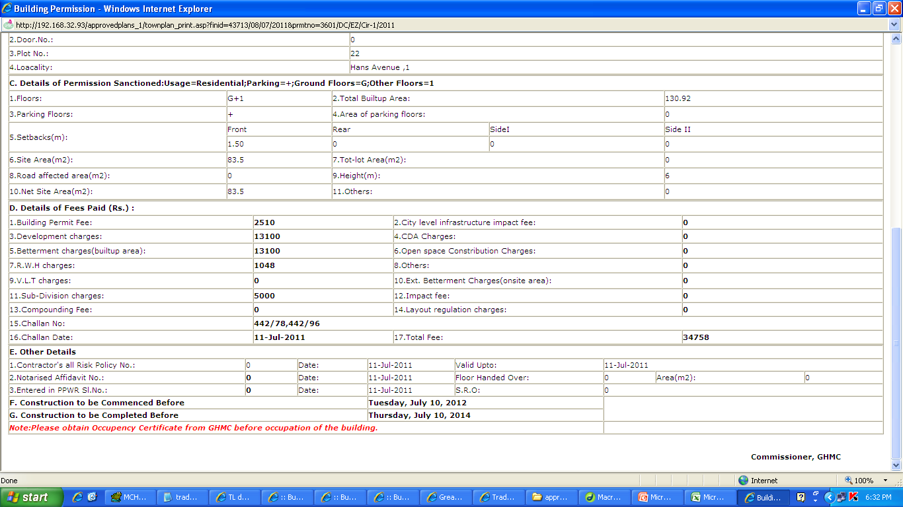

PDF File
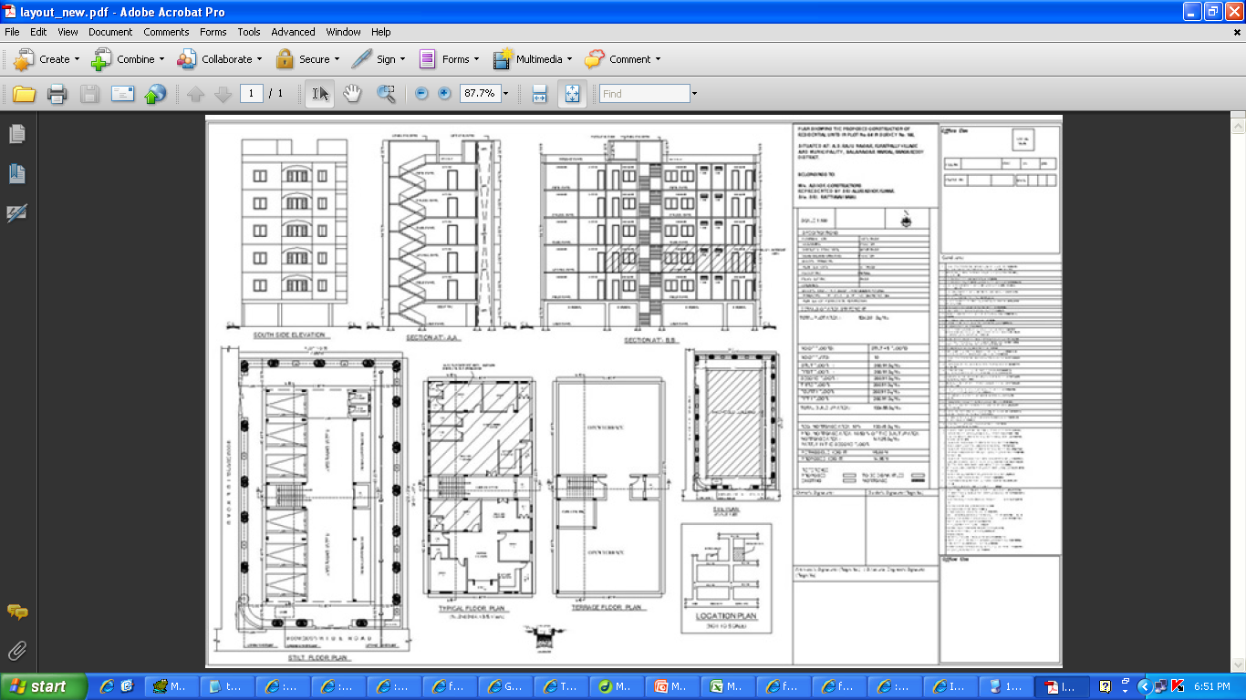

Occupancy Certificate
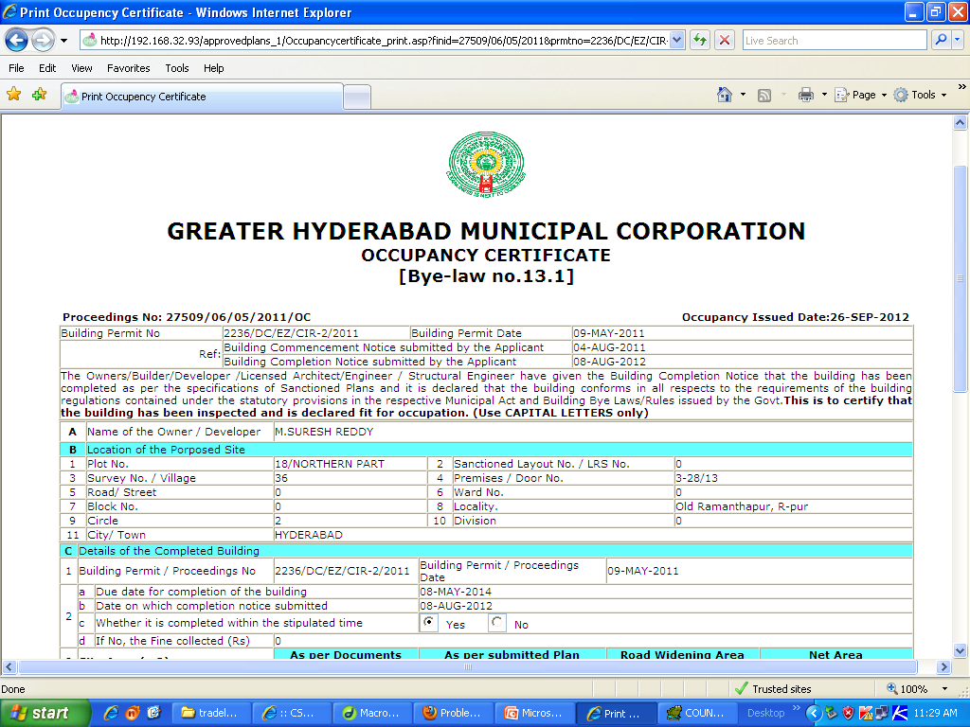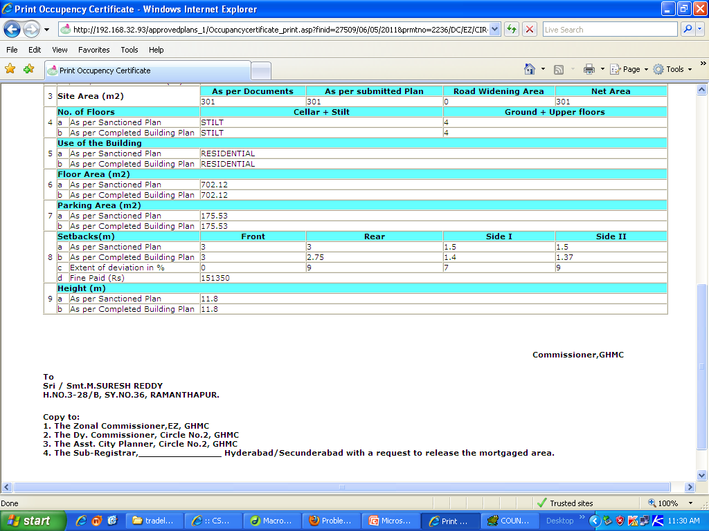

Occupancy Certificate issued in VMC
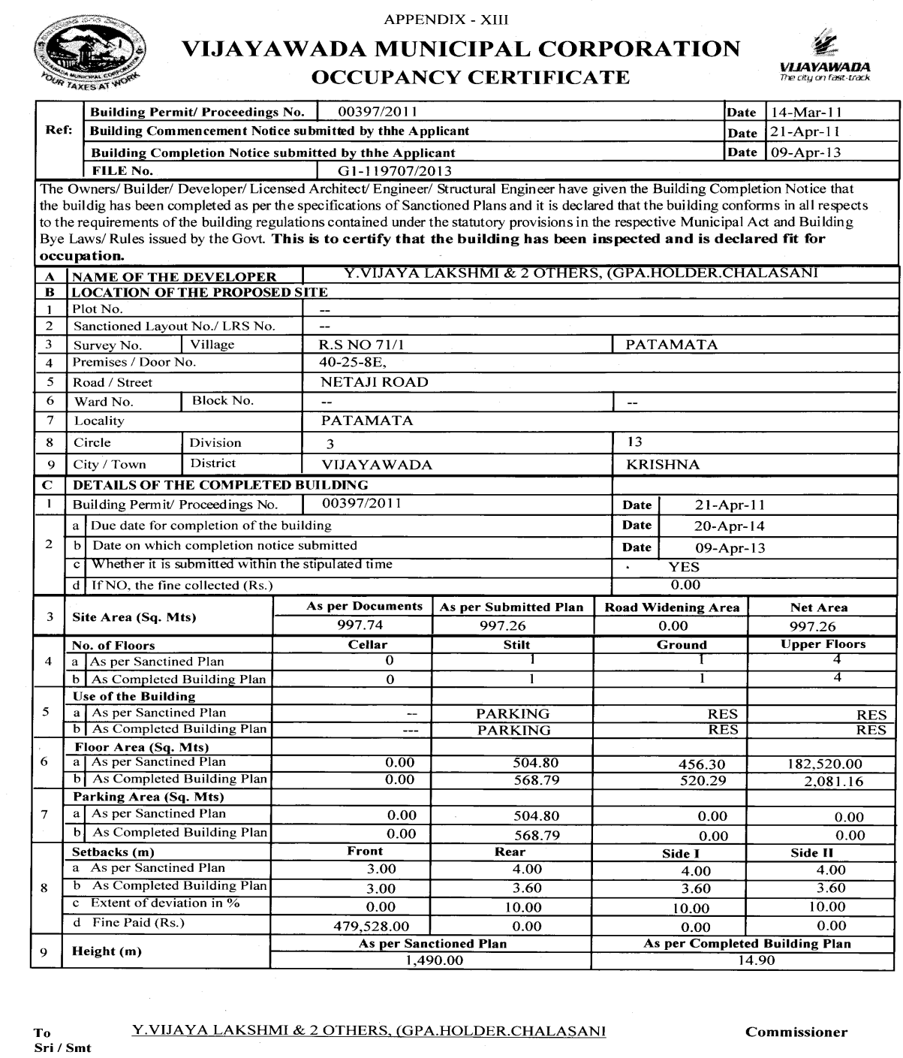

Occupancy Certificate issued in VMC
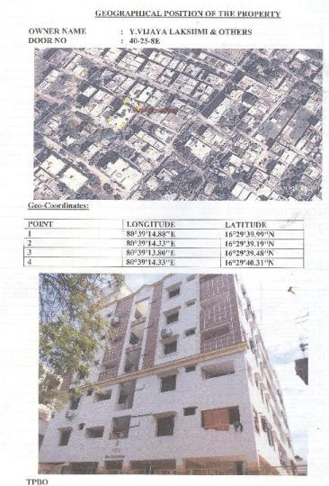

ROAD WIDENING

PURPOSE :
  - The purpose of road widening is to improve traffic circulation and the quality of the environment on selected congested roads.
  - Road widening ensures adequate road width in order to provide infrastructures facilities like drainage, electrification, Pedestrian foot path and avenue plantation works.
CONCESSIONS IN ROAD WIDENING CASES
  - Entitled for TDR or
  - Extra floor with equivalent built up area allowed or
  - Concessions in setback including front setback
  - In case of High rise Buildings the concessions in setbacks, other than the front setback would be considered

ENCOURAGEMENT FOR PROVISION OF PARKING COMPLEXES
  - Incentives like relaxation in setbacks, fee, moratorium on property tax are proposed

TRANSFERABLE DEVELOPMENT RIGHTS (TDR)

  - TDR means an award specifying the built up area an owner of a site or plot can sell or dispose or utilize elsewhere, in lieu of surrendering land free of cost which is required to be set apart or affected for public purpose as per the Master Plan or in road widening or covered in recreational use zone, etc.
  - TDR can be awarded only when such lands are transferred to the local body / Urban Development Authority as the case may be by way of registered gift deed.
  - The award would be in the form of a TDR certificate issued by the Competent Authority / Sanctioning Authority.
Norms
  - For the Master Plan Road / Road Development Plan undertaken and developed: equivalent to 200% of built up area of such area surrendered.
  - For conservation and development of lakes / water bodies / nalas foreshores & Recreational buffer development with greenery, etc: equivalent to 100% of built up area of such recreational buffer area developed at his cost.
  - For Heritage buildings and heritage precincts maintained with adaptive reuse: equivalent to 100% of built up area of such site area

